 | Mathematics AC V9 — Year 5
Unit 1
Assessment task 1.3 — Planning and conducting a statistical investigation about
sun safety ☼
The K–6 Curriculum Planning Model (K–6CPM) for Australian Curriculum V9 Mathematics supports systematic curriculum implementation in multilevel contexts across Kindergarten to Year 6. This flexible model streamlines content and assessments through aligned contexts.
The K–6CPM includes supplementary resources to support curriculum implementation in a range of schools including small schools and larger schools with complex and/or multilevel contexts.
This assessment task provides example questions and activities aligned to the aspects of the achievement standard being assessed. Individual school contexts will inform decisions about how the task is to be implemented and how students will engage with the task.
The assessment task gathers evidence of student learning for these aspects of the Year 5 Mathematics achievement standard:
- Plan and conduct statistical investigations that collect nominal and ordinal categorical and discrete numerical data using digital tools.
- Identify the mode and interpret the shape of distributions of data in context.
- Interpret and compare data represented in line graphs.
The following materials can be used when implementing Unit 1 in the K–6 Curriculum Planning Model Mathematics Year level plan example.
See the Mathematics Unit 1 Curriculum and assessment alignment planner (CAAP) to guide unit planning when developing a teaching and learning sequence and implementing the assessment in the unit.
Assessment conventions and resources
Purpose: To plan and conduct a statistical investigation to collect, represent and interpret nominal and ordinal categorical and discrete numerical data.
Technique: Statistical investigation.
Conditions:
- This task is to be completed individually.
- Can be completed over multiple sessions.
- Adapt the mode and conditions to suit the diverse learning needs of your students and school context.
Other resources:
- Digital tools, for example: online survey creator, word-processing program, spreadsheet, online graph maker, Learning object — Graphmaker 2
Mathematics teaching and learning resources
Visit the M in STEM website (https://det-school.eq.edu.au/m-in-stem) to access professional learning modules that support development of the mathematical proficiencies: Understanding, Fluency, Reasoning and Problem solving, including the mathematical processes: mathematical modelling, probability simulations and experiments, statistical investigations, and computational thinking.
Frameworks for the mathematical processes used when assessing the Problem solving proficiency can be found in the ‘Understand this learning area: Mathematics’ section of Australian Curriculum Version 9 website (https://v9.australiancurriculum.edu.au/teacher-resources/understand-this-learning-area/mathematics). These frameworks may provide support around the teaching and learning of the relevant mathematical process in the related unit of work.
Implementation advice
- Adapt this assessment task to suit the diverse needs of the students, school and local context.
- When adapting the assessment, maintain alignment to the targeted achievement standard aspects and aligned curriculum elements and consider ways to make the assessment meaningful and accessible for students.
- Answer spaces have not been included to provide flexibility in how and where students will respond.
- Each part of the summative assessment may be conducted as a series of smaller tasks to be used to gather evidence of student learning against the marking guide.
- The context of the statistical investigation is about sun safety. Students plan and conduct a statistical investigation to collect data to answer the key question: ‘Is our class sun smart?’
- Consider your cohort and change the topic of investigation and the key question if needed. For example: students may instead gather data to help organise an upcoming school event and answer the key question: ‘What makes the best school fete?’
Part A: Interpret and compare data represented in a line graph
- Line graphs are used to represent continuous numerical data. Continuous data changes over time, for example: wind speed, rainfall, UV levels.
- Data in the line graph may be adapted if you change the key question to suit your context, for example: local monthly rainfall.
Part B: Plan and conduct a statistical investigation about sun safety
- Students will pose questions to collect the following types of data:
- Ordinal categorical data involves categories with a clear order, for example: ‘How often do you wear a hat when outside/playing: always, sometimes or never?’; ‘How often do you wear sunscreen: always, sometimes or never?’
- Nominal categorical data involves categories with no particular order, for example: ‘Do you wear sunscreen every day: yes or no?’; ‘What type of sunscreen do you wear: 15+, 30+, 50+?’; ‘Where do you play at lunch time: library, playground, undercover area?’
- Discrete numerical data is a type of data that includes whole, concrete numbers with specific and fixed data values determined by counting, for example: ‘How many days a week do you wear sunscreen?’; ‘How many play areas in the school are shaded? ‘
- In order to meet the targeted achievement standard aspect, ‘Plan and conduct statistical investigations that collect nominal and ordinal categorical and discrete numerical data using digital tools’, identify opportunities for students to use digital tools in the assessment. For example:
- the survey can be conducted using an online survey creator, email or polling tools
- the data can be recorded using a spreadsheet, word-processing program or tablet
- the data can be represented using a spreadsheet, word-processing program or tablet.
☼ Source: Australian Curriculum www.australiancurriculum.edu.au, CC BY 4.0. © Australian Curriculum, Assessment and Reporting Authority (ACARA) 2010 to present, unless otherwise indicated. This material was downloaded from the Australian Curriculum website (www.australiancurriculum.edu.au) (Website) (accessed 10/10/24) and was modified. The material is licensed under CC BY 4.0 (https://creativecommons.org/licenses/by/4.0). Version updates are tracked in the ‘Curriculum version history’ section on the ‘About the Australian Curriculum’ page (http://australiancurriculum.edu.au/about-the-australian-curriculum/) of the Australian Curriculum website. ACARA does not endorse any product that uses the Australian Curriculum or make
any representations as to the quality of such products. Any product that uses material published on this website should not be taken to be affiliated with ACARA or have the sponsorship or approval of ACARA. It is up to each person to make their own assessment of the product, taking into account matters including, but not limited to, the version number and the degree to which the materials align with the content descriptions and achievement standards (where relevant). Where there is a claim of alignment, it is important to check that the materials align with the content descriptions and achievement standards (endorsed by all education Ministers), not the elaborations (examples provided by ACARA).

 | Mathematics AC V9 — Year 5
Unit 1
Assessment task 1.3 — Planning and conducting a statistical investigation about
sun safety

Name |  | Class
Teacher |  | Date
Part A: Interpret and compare data represented in a line graph
The sun’s ultraviolet radiation (UV) damages our skin. UV is an invisible danger because we can’t see or feel it. Scientists have created a UV index to help us know the UV levels and how high the UV exposure is at different times of the day. One way to be sun smart is to reduce our exposure to higher UV levels.
Look at the information shown on the line graph and UV index key.
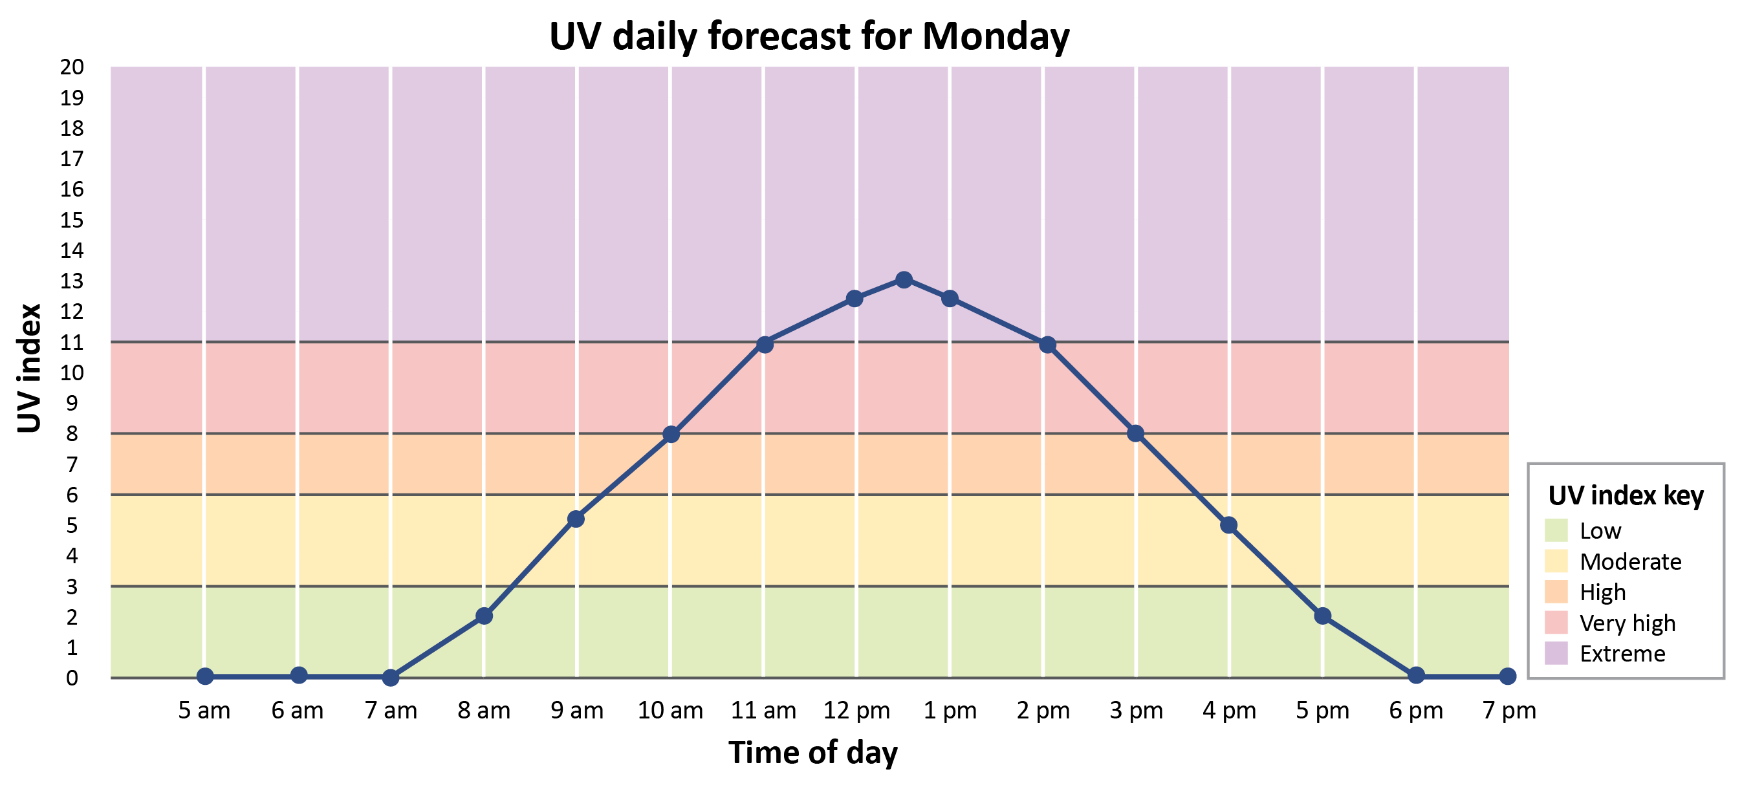
- What does the horizontal axis show?
- What does the vertical axis show?
- What is the UV level at 10am?
- What are the UV levels for moderate exposure?
- Which times of the day have very high exposure?
- What is the difference between the UV level at 11am and 3pm?
- Describe how the UV level changes throughout the day between 5am and 7pm.
- When are the safest times to play outside without a hat?
- What question could have been used to collect and represent the information in the line graph?

Part B: Plan and conduct a statistical investigation about sun safety
UNDERSTAND
It is important to be sun smart by protecting our skin from the sun’s UV radiation. Ways to be sun smart include wearing a hat and sunscreen.
You will plan and conduct a statistical investigation to collect data to answer this key question:
How sun smart is our class?
Think about the type of data you want to collect to find out if your class is sun smart.
- Choose three questions for your statistical investigation:
Question 1 | Question 2 | Question 3
Choose one (tick):  How often do you wear a hat when playing outside: always, sometimes or never?  How often do you forget to wear a hat when playing: always, sometimes or never? | Choose one (tick):  Do you wear sunscreen every day: yes or no?  What type of sunscreen do you wear: SPF 15+, 30+, 50+ or none? | Choose one (tick):  How many days a week do you wear sunscreen?  How many hours per day are you in the sun?
PLAN
- Plan how you will use digital tools to collect and record the data for your three chosen questions.
DO
- Follow the steps of your plan to collect data for your three chosen questions.
- Look at the data you collected for Question 1.
- What type of display will best represent the data? Why?
- Represent the collected data using your chosen display.
- Look at your data display.
- What is the mode (most frequent response)?
- What does the data tell you? List at least three findings. Hint: Think about the shape of distribution of data.
- Repeat steps 4 and 5 for the data you collected for Question 2 and Question 3.
CONSIDER and COMMUNICATE
How sun smart is our class?
- Analyse the data in your three data displays and share your findings.
- What other data would help support answering the key question? Pose another question that could be used to collect more data.
 | Marking guide — Year 5 Unit 1
AC V9 Mathematics | Name:
Assessment task 1.3 — Planning and conducting a statistical investigation about sun safety☼
Purpose: To plan and conduct a statistical investigation to collect, represent and interpret nominal and ordinal categorical and discrete numerical data.
 |  | Understanding and Fluency | Problem solving and Reasoning
 |  | Interpret and compare data represented in line graphs. | Plan and conduct statistical investigations that collect nominal and ordinal categorical and discrete numerical data using digital tools.  Identify the mode and interpret the shape of distributions of data in context.
A | Interprets and compares data represented in a line graph, makes a simple inference about UV exposure and poses a possible question based on the continuous numerical data. |  | Plans and conducts statistical investigations that collect nominal and ordinal categorical and discrete numerical data using digital tools, explains data display choices and poses a suitable question.  Draws conclusions about the key question by identifying the mode and analysing the shape of distributions in represented data.
B | Interprets and compares data represented in a line graph and makes a simple inference about UV exposure. |  | Plans and conducts statistical investigations that collect nominal and ordinal categorical and discrete numerical data using digital tools and explains data display choices.  Identifies the mode, interprets the shape of distributions of data in context and shares findings about the key question.
C | Interprets and compares data represented in line graphs. |  | Plans and conducts statistical investigations that collect nominal and ordinal categorical and discrete numerical data using digital tools.  Identifies the mode and interprets the shape of distributions of data in context.
D | Reads and interprets data in a line graph. |  | Conducts a statistical investigation, and represents and interprets collected data, including mode, in chosen data displays.
E | Reads a line graph to identify information represented on the horizontal or vertical axis. |  | Conducts a statistical investigation, and represents and interprets collected data in a chosen data display.
Feedback:

Model response
The model response is a high-standard example. Different responses remain valid as long as students demonstrate the identified aspects of the achievement standard and standard descriptors of the marking guide.
Part A: Interpret and compare data represented in a line graph
Look at the information shown on the line graph and UV index key.
- What does the horizontal axis show? Answers will vary, for example: Time of day; the times; the hours.
- What does the vertical axis show? Answers will vary, for example: UV index; UV level; level of radiation.
- What is the UV level at 10am? 8.
- What are the UV levels for moderate exposure? 3–6.
- Which times of the day have very high exposure? 10–11 am; 2–3 pm.
- What is the difference between the UV level at 11am and 3pm? UV 11 – UV 8 = 3 levels.
- Describe how the UV level changes throughout the day between 5am and 7pm. Answers will vary, for example: The UV level starts low, gets higher towards the middle of the day and then it gets lower again at the end of the day.
- When are the safest times to play outside without a hat? Answers will vary, for example: The best time to play outside without a hat is either before 8am or after 5pm. The shape of the data tells me that this is when the UV level is at the lowest and so there will be less risk of exposure to high UV.
- What question could have been used to collect and represent the information in the line graph? Answers will vary, for example: When is the best time to go outside during the day without a hat? What are the UV levels throughout the day?
Part B: Plan and conduct a statistical investigation about sun safety
UNDERSTAND
- Answers will vary, for example:
Question 1 | Question 2 | Question 3
Choose one (tick):  ☒ How often do you wear a hat when playing outside: always, sometimes or never?  ☐ How often do you forget to wear a hat when playing: always, sometimes or never? | Choose one (tick):  ☐ Do you wear sunscreen every day: yes or no?  ☒ What type of sunscreen do you wear: SPF 15+, 30+, 50+ or none? | Choose one (tick):  ☒ How many days a week do you wear sunscreen?  ☐ How many hours per day are you in the sun?
PLAN
- Plan how you will use digital tools to collect and record the data for your three chosen questions.

DO
- Follow the steps of your plan to collect data for your three chosen questions. Answers will vary, for example:
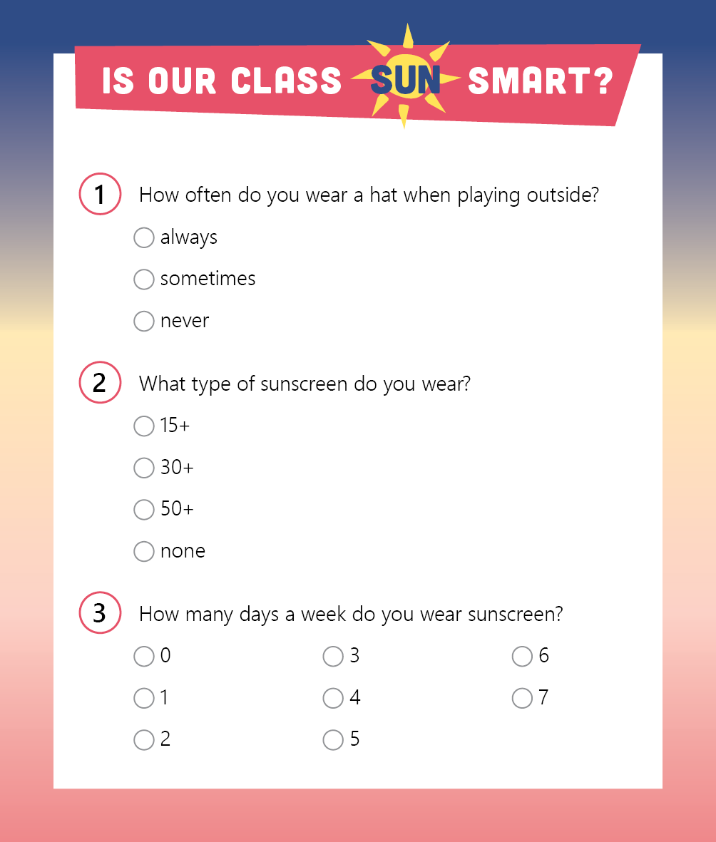 | This student has used an online survey creator to conduct their statistical investigation using their chosen three questions. Other ways to use digital tools to plan and conduct statistical investigations may include: email, word-processing program, polling tools.
- Look at the data you collected for Question 1. Answers will vary, for example:
How often do you wear a hat when playing outside? | Students | Total
Always |  | 15
Sometimes |  | 7
Never |  | 3

- What type of display will best represent the data? Why? Answers will vary, for example: I will use a dot plot because it will let me clearly see all the data and allow a quick comparison of the data.
- Represent the collected data using your chosen display.
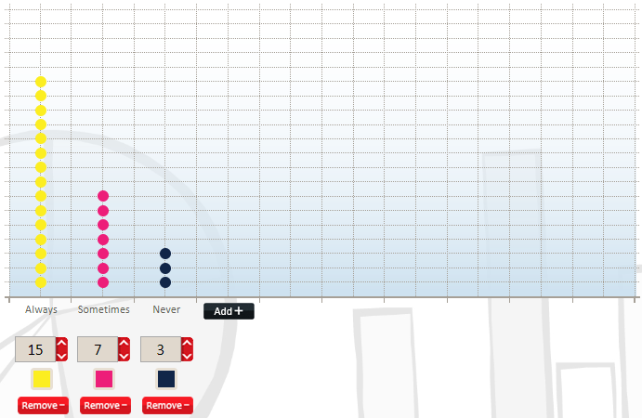
Wearing a hat outside
- Look at your data display.
- What is the mode (most frequent response)? For example: The mode is ‘always’.
- What does the data tell you? List at least three findings. Hint: Think about the shape of distribution of data. For example:
25 students were surveyed.
15 students ‘always’ wear a hat outside.
7 students ‘sometimes’ wear a hat outside.
3 students ‘never’ wear a hat outside.
The graph tells me that most students wear a hat when outside.

- Repeat steps 4 and 5 for the data you collected for Question 2 and Question 3.
Question 2
4. Answers will vary, for example:
What type of sunscreen do you wear? | Students | Total
SPF 15+ |  | 5
SPF 30+ |  | 8
SPF 50+ |  | 12
None |  | 0
a. What type of display will best represent the data? Why? Answers will vary, for example: I will use a many-to-one picture graph because I can quickly show and compare the data to know that most people wear 50+ sunscreen.
b. Represent the collected data using your chosen display. Answers will vary, for example:
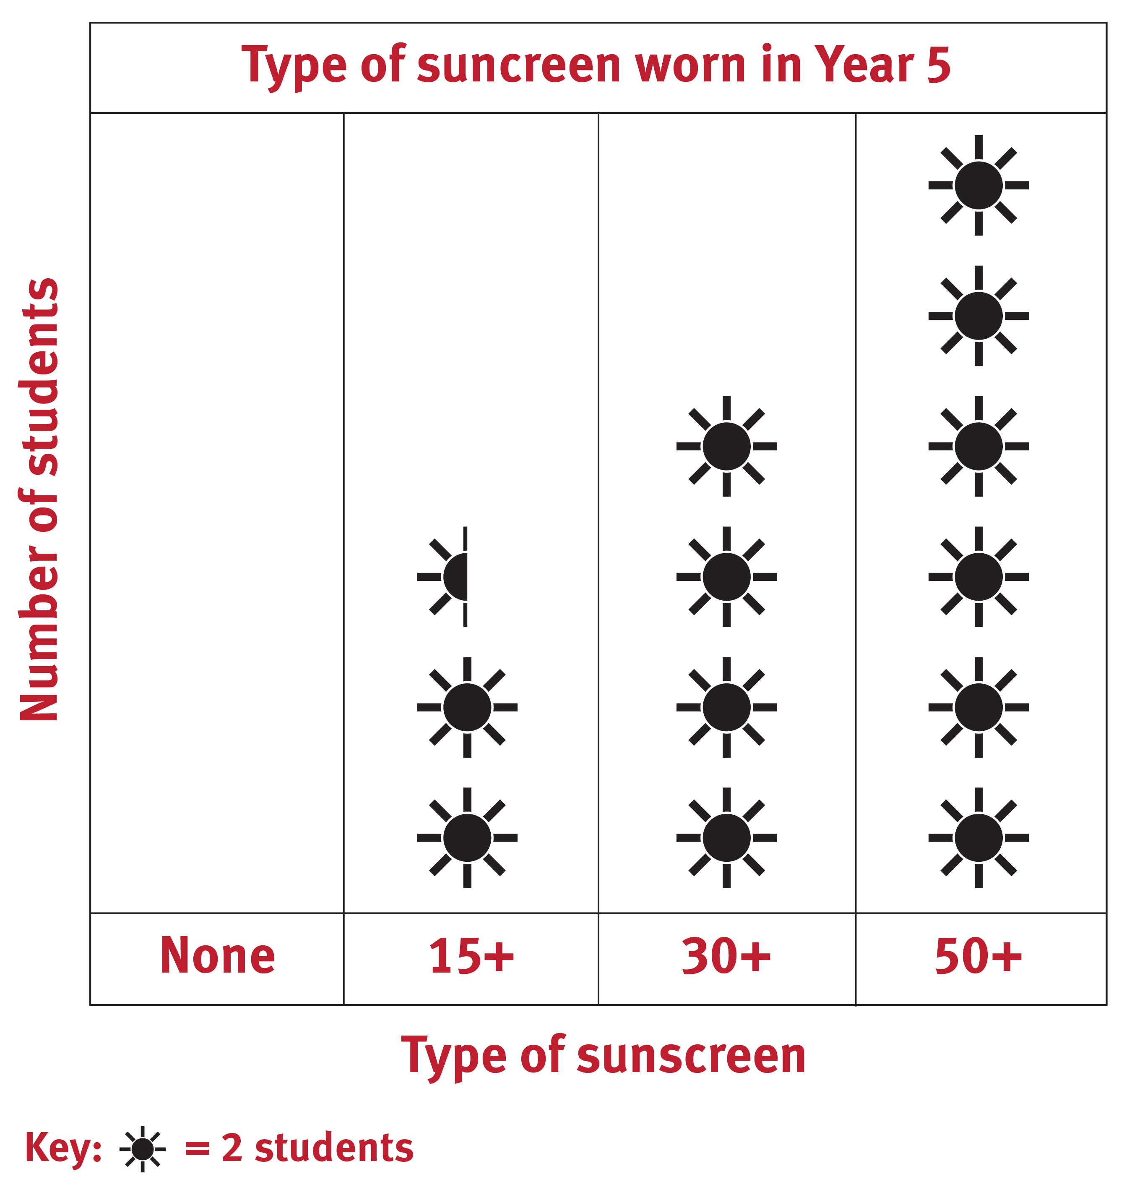
5. Look at your data display.
a. What is the mode (most frequent response)? For example: The mode is SPF 50+.
b. What does the data tell you? List at least three findings. Hint: Think about the shape of distribution of data. For example:
25 students were surveyed.
12 students wear SPF 50+.
8 students wear SPF 30+ sunscreen.
5 students wear SPF 15+ sunscreen.
The shape tells me that most students wear 50+ sunscreen.
Question 3
4. Answers will vary, for example:
How many days a week do you wear sunscreen? | Number of students | Total
0 |  | 1
1 |  | 1
2 |  | 1
3 |  | 1
4 |  | 2
5 |  | 2
6 |  | 7
7 |  | 10
a. What type of display will best represent the data? Why? Answers will vary, for example: I will represent my data in a horizontal column graph. It is the best way to represent my data because the columns are clear and easy to read when both axes are numbers; therefore, the data is easy to interpret and compare.
b. Represent the collected data using your chosen display. Answers will vary, for example:
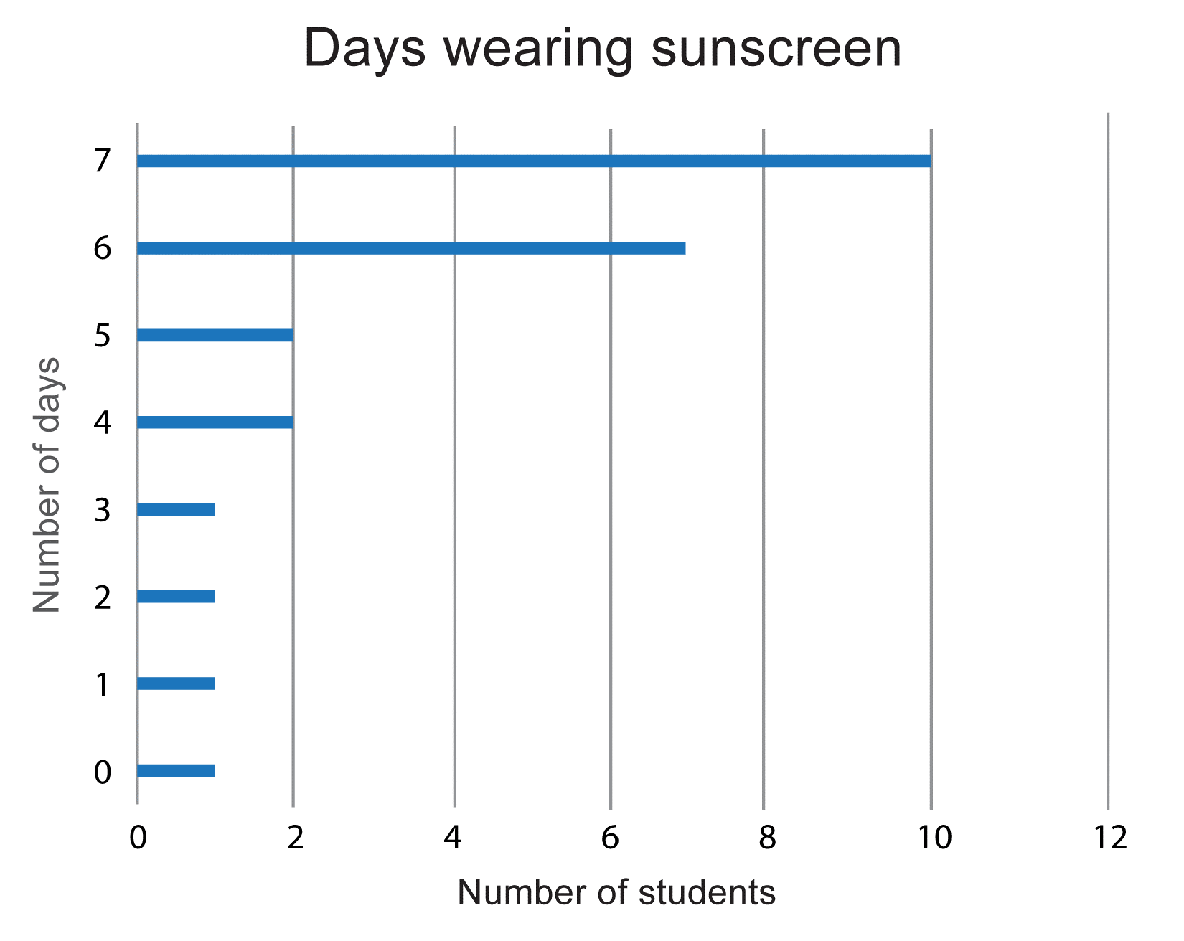
5. Look at your data display.
a. What is the mode (most frequent response)? For example: The mode is 7.
b. What does the data tell you? List at least three findings. Hint: Think about the shape of distribution of data. For example:
25 students were surveyed.
10 students wear sunscreen every day of the week.
7 students wear sunscreen 6 days a week.
2 students wear sunscreen 5 days a week.
2 students wear sunscreen 4 days a week .
1 student each wear sunscreen 0, 1, 2, and 3 days a week.
Most students wear sunscreen 6 or 7 days a week.
The same number of students wear sunscreen 4 to 5 days a week .
The same number wear sunscreen 0 to 3 days a week.
CONSIDER and COMMUNICATE
- Analyse the data in your three data displays and share your findings.
Answers will vary, for example: I believe my class is sun smart. The data I collected in my investigations support this conclusion and shows that students are wearing hats and a high factor sunscreen on most days of the week. The shape in the graphs shows that always wearing a hat outside, wearing 50+ sunscreen and wearing sunscreen 7 days a week are the highest responses. The mode shows that wearing sunscreen 7 days a week is the most frequent response.
Overall, the data shows that students in my class are sun smart because they wear a high SPF sunscreen and wear a hat most days when outside to protect their skin against harmful UV rays.
- What other data would help support answering the key question? Pose another question that could be used to collect more data.
Answers will vary, for example: ‘What type of hats do you wear?’ would collect data to show whether students are wearing sun smart hats.

